Scalar Encoder with Buckets

Aqib Javed
aqib.javed@stud.fra-uas.de

Abstract— Scalar encoders with buckets, prove valuable in scenarios requiring the conversion of continuous values into discrete entities. Widely employed in machine learning and data analysis, this method facilitates the transformation of continuous attributes like age, weight, or temperature into categorical features suitable for integration into models or algorithms. Sensor data analysis stands out as a prevalent application for scalar encoders. The buckets approach effectively addresses challenges such as limited precision, inflexibility, and Periodic Encoding. Consequently, the accuracy of scalar encoders is constrained by the mapping of continuous input values to a discrete dataset, leading to decreased adaptability and increased difficulty in customization for diverse datasets. This challenge arises from the user's need to specify parameters like the number of min/max values and radius. Additionally, non-periodic encoding poses a constraint for scalar encoders, particularly in the context of specific input data. This paper examines the limitations of scalar encoders and explores potential solutions through their integration with the bucket approach.

Introduction
Scalar value encoding is a fundamental operation in machine learning, used in a wide range of applications. Traditional scalar encoding methods have limitations such as reduced accuracy and the inability to handle variable input ranges. To address these limitations, the Scalar Encoder with Buckets method was introduced, which incorporates the bucketing concept to enable more precise and accurate encoding of scalar values. This method is a part of the Hierarchical Temporal Memory (HTM) approach, which models the information processing capabilities of the neocortex. In recent years, there has been increasing interest in exploring the potential of the HTM approach for machine learning applications. One important aspect of this exploration is the development of effective encoding methods that can accurately and efficiently convert real-world data into a format suitable for use in HTM systems [1].

Hierarchical Temporal Memory (HTM) is a biomimetic model crafted on the principles of memory predictions, meticulously devised by scientists to emulate the architectural and algorithmic features inherent in the neocortex [4]. Demonstrating considerable promise in pattern recognition, HTM exhibits the ability to comprehend temporal sequences and the spatial flow of sensory inputs as data.
Utilizing a scalar encoder paired with buckets allows the conversion of continuous data into a set of discrete values, suitable for analysis, modeling, or machine learning. This method involves segmenting the range of continuous values into discrete intervals, commonly referred to as "buckets," with each value assigned to its respective bucket. The encoding process offers flexibility, accommodating various approaches and customization based on the specific needs of the application, such as employing a binary or multi-level encoding scheme. Scalar encoders with buckets find frequent use in applications such as sensor data analysis, natural language processing, and picture classification, proving to be effective tools for the transformation of continuous data into discrete formats.

LITERATURE SURVEY

Hierarchical Temporal Memory (HTM)

Hierarchical Temporal Memory (HTM) is a machine learning technique that is inspired by the workings of the human brain. It is based on the principles of the neocortex, which is responsible for higher-level functions such as perception, language, and cognition. HTM uses a hierarchical structure of algorithms to learn and process information. Each layer of the hierarchy processes information at a different level of abstraction, with higher-level layers processing more abstract concepts. The algorithms used in HTM are also designed to be able to handle noisy and incomplete data, and to learn continuously without the need for large amounts of training data. One of the key advantages of HTM is its ability to handle temporal data. HTM is designed to learn sequences of data, and to recognize patterns and anomalies in those sequences. This makes it well-suited for applications such as anomaly detection, prediction, and classification in domains such as finance, healthcare, and security. There have been several studies that have demonstrated the effectiveness of HTM in various applications. One study focused on the problem of predicting solar energy production [2]. HTM was able to make accurate predictions of solar energy production based on historical data, outperforming traditional machine learning techniques such as artificial neural networks. Another study focused on the problem of predicting traffic flow [3]. HTM was able to accurately predict traffic flow based on historical data and was also able to adapt to changing traffic patterns over time.
Overall, HTM shows promise as a machine learning technique that is well-suited for handling temporal data and recognizing patterns in that data. Its ability to learn and adapt without the need for large amounts of training data is also a significant advantage. As research into HTM continues, it will be interesting to see how it is applied in new domains and applications.

Sparse Distributed representations (SDRs)

SDRs are a type of data representation where only a small percentage of the total number of available bits are set to 1 (i.e., active), while the remaining bits are set to 0 (i.e., inactive). This sparse binary representation allows SDRs to capture the essential features of the input data in an efficient and flexible manner.
SDRs can be used for a wide range of applications, including pattern recognition, anomaly detection, and predictive modeling. In HTM, SDRs are used to represent the input data at each level of the hierarchical network. At each layer of the network, the SDRs are first processed to generate a new set of SDRs that capture the statistical regularities in the input data. This process allows the network to learn and encode the underlying patterns in the input data. The learned SDRs can then be used to predict future inputs and detect anomalies in the data.
In an HTM system, an encoder first translates a data source into a Sparse Distributed Representation (SDR). To encapsulate the primary semantic characteristics of the material, the encoder determines which output bits should be set to one and which should be set to zero. SDRs sharing similar input values are expected to exhibit a substantial degree of overlap [3]. 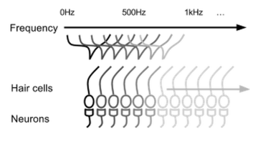
Figure.1: Cochlear hair cells excite a group of neurons based on the frequency of the sound.

Encoders

Encoders play a crucial role in converting raw input data into Sparse Distributed Representations (SDRs), making them suitable for processing in Hierarchical Temporal Memory (HTM) networks. Various types of encoders are employed to handle different data types, such as Scalar Encoders for continuous scalar values, Category Encoders for categorical values, Date Encoders for dates and times, and Coordinate Encoders for spatial coordinates.

When determining the ideal values for the constant number of bits 'N' and the fixed number of active bits 'W' in SDRs, a delicate balance must be maintained. To preserve the benefits of sparsity, 'N' should not be excessively large. However, if 'W' is too small, the advantages of a distributed representation may be compromised.

Several unique aspects need consideration during data encoding:

Consistency is crucial, ensuring that the same input consistently produces the same SDR output. This deterministic quality is vital for effective learning in HTM networks. The output dimensionality of the encoder must match the total number of bits across all inputs, maintaining a consistent representation size.

Deterministic encoders are essential, as they generate the same result from identical inputs on each occurrence. This characteristic is vital for preventing redundancy in the learned sequences within HTM, as encoded representations must maintain stability over time. Encoders should avoid introducing adaptive or random elements to ensure the reliability of learned patterns.

Moreover, it is imperative that the output of an encoder consistently produces the exact same number of bits for each input. SDRs rely on bit-by-bit assumptions for comparisons and handling, emphasizing the importance of uniformity in bit length. Offering various SDR bit lengths would hinder operations like comparisons, potentially compromising the effectiveness of HTM networks [4].

Methodology

The Scalar Encoder and Scalar Encoder with Buckets are algorithms employed in machine learning and artificial intelligence to convert scalar values into high-dimensional, sparse binary representations. These algorithms are integrated into the Neocortex API, an open-source platform aligned with the principles of Hierarchical Temporal Memory (HTM) theory, a biologically inspired framework for understanding sensory input processing and learning in the brain.
To utilize the Scalar Encoder in the Neocortex API, one must instantiate the Scalar Encoder class, configuring parameters such as the number of active bits, encoding width, and input range. Subsequently, the encode method is called to transform a scalar value.
The Scalar Encoder maps continuous scalar data onto a specified range of integers, creating sparse distributed representations (SDRs). It calculates SDR bit count and bucket width by determining a scaling factor and resolution. The scalar value is then encoded into an SDR using one-hot encoding, rounded to the nearest integer. An alternative approach is the Scalar Encoder with Buckets, which adapts bucket widths based on data distribution, employing a clustering technique to classify similar values into buckets of varying sizes. This method can be more effective when dealing with uneven data distributions compared to a fixed-width scalar encoder.
In the realm of data encoding, a fixed-width scalar encoder divides the input value range into identically sized bins, with each bin representing a specific value range. This straightforward approach ensures consistent and predictable output representations for input values.

Sparse Distributed Representation

Within the framework of Hierarchical Temporal Memory (HTM), the Sparse Distributed Representation (SDR) emerges as a highly efficient system for organizing information. The term "sparse" denotes that only a small percentage of the interconnected cells are active at any given instance. Furthermore, the descriptor "distributed" signifies that these active cells are dispersed throughout the region, capturing the comprehensive activity of the entire area. HTM opts for the binary SDR, converted from a specific encoder, owing to its closer alignment with biological principles and its notable computational efficiency.

Even though the potential inputs outnumber the conceivable representations, the conversion to a binary SDR doesn't result in a loss of functional information. This resilience is attributed to the indispensable features embedded in the SDR, ensuring the preservation of crucial aspects without compromising informational integrity.
An example of an SDR shown below:
X = 0000000000000000001111100000000000000000
In this example, the SDR has a length of 40 and represents a set of binary values. Only a small subset of the bits is active (i.e., set to 1), while the rest are inactive (i.e., set to 0). The exact number of active bits in an SDR can vary depending on the desired level of sparsity, but typically only a small percentage of bits are active. SDRs are a powerful tool in machine learning and are essential to the functioning of HTM. Their ability to represent patterns and relationships in data in a compact and efficient manner makes them well-suited for a wide range of applications.

Scalar Encode
The Scalar Encoder is a type of encoding method used in Hierarchical Temporal Memory (HTM) to represent scalar data. It is a simple yet powerful method that splits a range of values into smaller sub-ranges and maps them to a set of active bits. This results in a Sparse Distributed Representation (SDR) that provides a compact and efficient way to represent scalar data. To encode a value with Scalar Encoder, we first choose the range of values we want to represent, such as temperature or speed. Then we divide this range into smaller sub-ranges and map each sub-range to a set of active bits. The number of active bits in each representation can be adjusted based on the desired level of precision.
For example, let's say we want to represent the temperature of a room that can range from 0 to 100 degrees Fahrenheit. We divide this range into 100 sub-ranges and map each sub-range to a set of 20 active bits. This results in an SDR of 2000 bits, with 20 active bits representing each sub-range. Suppose the temperature in the room is 72 degrees Fahrenheit. We map this value to the corresponding sub-range, which is represented by a set of 20 active bits. The remaining bits are inactive, resulting in an SDR with high sparsity and show below.

...……00000000000000111111111111111111000000000……….

The Scalar Encoder is a basic encoding method that can be used to represent a wide range of scalar data. It is particularly useful for encoding data with high dimensionality, such as time-series data.

Scalar Encoder with Bucket

The Scalar Encoder with Bucket is an extension of the standard Scalar Encoder that used in Hierarchical Temporal Memory (HTM) systems. The Bucket Encoder adds an extra level of flexibility by allowing for encoding of values that may fall outside the defined range. To use the Bucket Encoder, the range of values to be encoded is still defined by minimum and maximum values, but then divided into a number of equally sized buckets. Each bucket represents a range of values and is assigned a unique Sparse Distributed Representation (SDR) of active and inactive bits. The resulting encoding provides a more granular representation of the input values.
A simple scalar encoder encodes scalar values by mapping them to fixed-size bit arrays, where each bit represents a binary value of the input scalar. For example, if we have a scalar value of 2.5 and we want to encode it using a simple scalar encoder with 10 bits, the resulting bit array could be [0, 0, 1, 0, 0, 0, 0, 0, 0, 0].
The main disadvantage of this approach is that the encoding is not very precise, as two scalar values that are very close to each other can result in very different bit arrays. For instance, if we want to encode the scalar value of 2.6 using the same simple scalar encoder with 10 bits, the resulting bit array could be [0, 0, 0, 1, 0, 0, 0, 0, 0, 0], which is significantly different from the bit array we obtained for the scalar value of 2.5.
On the other hand, a scalar encoder with buckets uses a more flexible encoding scheme that allows for more precise and accurate encoding of scalar values. Instead of mapping scalar values to fixed-size bit arrays, the scalar encoder with buckets maps scalar values to a set of overlapping buckets. Each bucket is defined by a center value and a radius, and scalar values that fall within the radius of a bucket are encoded using the same bit array.
For example, if we have a scalar value of 2.5 and we want to encode it using a scalar encoder with buckets, we can define a bucket with a center value of 2.5 and a radius of 0.1. The resulting bit array for the scalar value of 2.5 would be the same as the bit array for any scalar value that falls within the radius of the defined bucket, such as 2.4 or 2.6. This approach allows for a more precise and accurate encoding of scalar values, as scalar values that are very close to each other are more likely to be encoded using the same bit array.

In the realm of fixed-width bucketing, a continuous range of values is divided into a set number of equal-sized buckets. Let's explore a couple of instances:

Text Length Categorization: Imagine you want to categorize text lengths into groups such as short, medium, and long. Employing fixed-width bucketing involves dividing the range of text lengths (e.g., 0 to 1000 characters) into equal-sized buckets (e.g., 250 characters).

Customer Purchase Amount: Suppose you aim to classify customer purchase amounts into different spending tiers like low, moderate, and high. Utilizing fixed-width bucketing entails dividing the purchase amount range (e.g., $0 to $5000) into equal-sized buckets (e.g., $1000).

Product Rating Ranges: Consider a scenario where you want to categorize product ratings as low, medium, and high. Fixed-width bucketing can be applied by segmenting the rating range (e.g., 1 to 10) into equal-sized buckets (e.g., 3 points).

implementation

When developing encoders for Hierarchical Temporal Memory (HTM) systems, ensuring determinism is paramount for maintaining consistent outputs with identical inputs. It is advised to steer clear of random or adaptive-element encoders during the construction phase. Additionally, encoding outputs should maintain a uniform bit length for each input, enabling efficient comparison and manipulation of Sparse Distributed Representations (SDRs).

Equally critical is the need for the encoder's output to contain an adequate number of one-bits, typically recommended to be in the range of 20-25. This ensures resilience to noise and non-deterministic factors, preventing errors within the HTM system. Insufficient one-bits in the representation, fewer than 20, may compromise performance and increase vulnerability to errors stemming from noise and non-determinism.
In the process of constructing an encoder implementation, the initial step involves dividing the value range into buckets and subsequently mapping these buckets to a set of active cells.
1) Establish the value range by determining MinVal and MaxVal.
2) Range = (MaxVal - MinVal) * 2.
3)Determine the "width" of the output signal "W," representing the number of bits set to encode a single value.
4)Select the total number of bits in the output, denoted as "N," serving as the representational bit count.
5)Utilize a periodic or non-periodic parameter to calculate the resolution.
6)Initiate the encoding process by starting with N unset bits, gradually setting them one at a time to form the encoded representation.

Scalar Encoder with Bucket Implementation
A scalar encoder functions by converting a numerical (floating-point) value into a binary array, predominantly composed of zeros except for a continuous block of ones. This block dynamically adjusts its position based on the real-time input value, utilizing linear encoding. For nonlinear encoding, one can modify the scalar input before encoding, potentially through the application of a logarithmic function.

It is imperative to avoid discretizing data during preprocessing, such as mapping "1" to a specific range, as it results in information loss and hampers the overlap of neighboring values in the output. A continuous transformation that scales the data is preferred, with "MaxVal" serving as a valid upper limit. Key parameters include "w" (width of the output signal, requiring oddness to prevent centering issues), "MaxVal" (maximum input value or a valid upper limit if periodic is true), and "periodic" (indicating if the input value wraps around).

The parameter "n" specifies the number of bits in the output, with "w" needing to be equal to or greater than the representations of two inputs separated by more than the radius to ensure non-overlapping representations. The radius denotes the input range, and the resolution determines when inputs will consistently have distinct representations. Additional parameters may include "name" (a string for description) and "clip Input" (trimming non-periodic inputs outside MinVal/MaxVal if true). Safety tests can be omitted if specified as true, with "radius" and "resolution" being relative to the input, while "w" is relative to the output.

Consider an alternative scenario, such as encoding temperature sensor readings using a scalar encoder. The width of the output signal, denoted as "w," must be an odd number to avert centering issues. The upper limit for temperature, referred to as "MaxTemp," is taken into account, and the encoding considers whether temperature values wrap around, depending on the periodic parameter. The specified number of bits in the output, "n," ensures that representations of two temperature values separated by a defined range do not overlap, with the radius defining the temperature range. The resolution specifies when distinct temperatures always result in different representations. Optional parameters like "name" for description and "clip Input" for trimming non-periodic inputs can be included. Safety tests, if set to true, permit skipping certain checks, with "radius" and "resolution" being relative to the temperature input, and "w" relative to the binary output.(Fig 2)
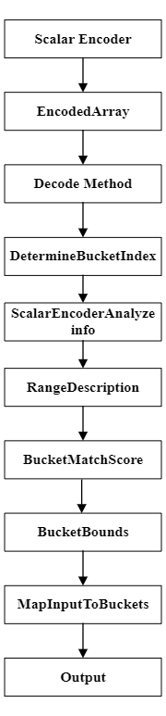
Fig 2: graphical representation of the scalar encoder with Bucket methods

GenerateNumericRangeDescription:
The GenerateNumericRangeDescription method is designed to provide a descriptive overview of the bucket ranges utilized for encoding input data. This feature is instrumental in helping users grasp the intricacies of the encoding scheme, empowering them to fine-tune parameters as necessary. By offering this capability, the Scalar Encoder with Buckets becomes even more versatile, ensuring ease of adaptation to diverse datasets and enhancing its overall flexibility. (Fig 3)
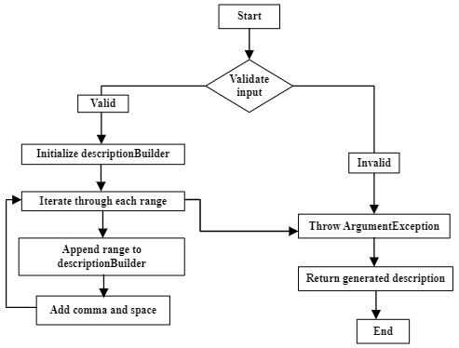

Fig 3: graphical representation of the Generate Numeric Range Description
ScalarEncoderDetermineBucketIndex:
The ScalarEncoderDetermineBucketIndex method is crafted to ascertain the bucket index for a provided decimal input value within the context of a scalar encoder. The initial step involves a check to ascertain whether the input value falls outside the valid range, resulting in a null outcome if it does. Following this, the method proceeds to calculate a normalized fraction based on the input value, taking into account any applicable periodic conditions. The normalized fraction is then employed to determine the initial bucket index. When managing periodic conditions, the method incorporates procedures for wrapping around to the first bucket in case the index equals the total number of buckets and adjusting the index based on specific epsilon threshold conditions.

Furthermore, the method performs an additional check to verify if the input value falls within the specified bucket radius, making use of the IsWithinBucketRadius private method. This auxiliary method involves computations for determining the bucket width, identifying the bucket center, and examining whether the absolute difference between the input value and the bucket center is within the defined bucket radius. If the input adheres to all specified conditions, the method yields the determined bucket index; otherwise, it returns a null result. The code structure is enhanced by the inclusion of private helper methods such as CalculateNormalizedFraction and CalculateBucketIndex, contributing to a modular and well-organized functional design. This particular implementation appears to be an integral part of a broader system focused on the scalar encoding of decimal values into discrete buckets, taking into consideration periodic conditions and constraints related to the bucket radius. (Fig 4)
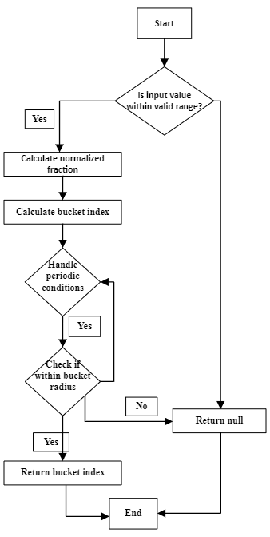
Fig 4: graphical representation of the Scalar Encoder DetermineBucketIndex method
DetermineBucketBounds:
The primary objective of the DetermineBucketBounds method is to calculate the lower and upper boundaries of the bucket to which a given numeric value is assigned. The process begins by addressing special cases, checking for invalid numbers, NaN, or infinity values, and appropriately raising exceptions when necessary. Subsequently, the code validates whether the provided value falls within the predefined range of the encoder, triggering an exception if it exceeds the specified limits. The method then proceeds to compute the width of each bucket based on the established range and the total number of buckets.

To enhance robustness, special considerations are implemented to handle potential issues with the bucket width, such as situations where it may be infinity, NaN, or a non-positive value. Additionally, the inclusion of console print statements in the code serves the purpose of offering insights into the calculated bucket width and index. This feature aids in debugging and provides valuable information during the implementation phase.

Following the calculations, the determined lower and upper bounds of the bucket are printed. The method finalizes its operation by returning an array containing these boundaries. The significance of this method is underscored in its role within a broader system that involves encoding numerical values into discrete buckets within a specified range. The thorough error handling and the inclusion of debug output statements underscore a commitment to ensuring accuracy in bucket assignment and facilitating effective debugging throughout the development process. (Fig 5)

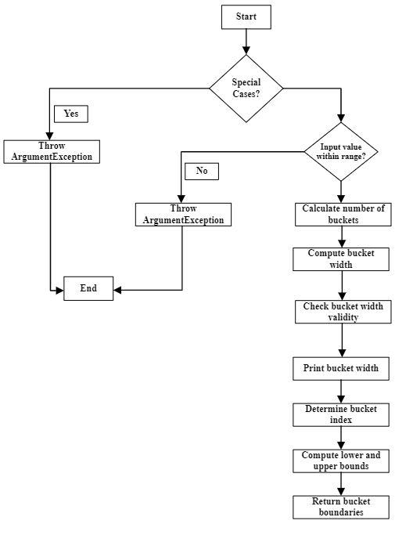
Fig 5: graphical representation of the DetermineBucketBounds method
MapInputToBuckets:
MapInputToBuckets method, designed to map an input value to a binary representation stored in an array based on a specified number of buckets. The mapping strategy is determined by the periodicity of the encoder. If the encoder is periodic, the method utilizes the MapPeriodicInput function, calculating the width of each bucket and setting binary mapping based on the distance from the input. In the case of non-periodic encoding, a similar logic is applied using the MapNonPeriodicInput function. Both mapping functions calculate the bucket index, loop through each bucket, and determine the binary mapping based on the distance from the input. The resulting binary mappings are stored in an integer array, providing a concise and modular implementation for mapping input values to binary representations based on periodic or non-periodic encoding conditions. (Fig 6)
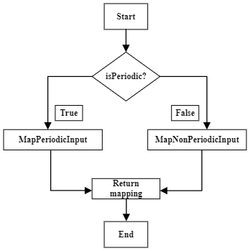

Fig 6: graphical representation of the MapInputToBuckets method
ScalarEncoderAnalyzeinfo:
The ScalarEncoderAnalyzeinfo method furnishes details about the associated bucket within the scalar encoder, presenting the information in an int array. This method operates by taking a double input value.

By checking whether the input value exceeds the maximum or falls below the minimum, the algorithm initially confines the input value within the scalar encoder's range.

After dividing the encoder's range into N buckets, the algorithm identifies the specific bucket to which the input value belongs, calculating the index accordingly. Given that the bucket index is derived through integer division, it will consistently result in an integer.

Next, the algorithm determines the center of the bucket by multiplying the initial value of the bucket by half of its width. It also computes the starting and ending values of the bucket.

In the case of a periodic encoder, the approach involves wrapping the bucket index when it surpasses N buckets. Considering the encoder's periodicity, the algorithm calculates the distances to the nearest bucket edges. The bucket's center is determined by the method using the nearest edge.

The final output of the method encompasses a rounded bucket center value, a rounded bucket starting value, a rounded bucket ending value, and an int array containing the bucket index. These values collectively serve to represent the input value in the scalar encoder as an array of binary digits. (Fig 7)

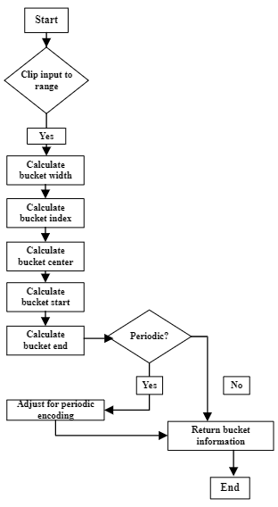
Fig 7: graphical representation of the ScalarEncoderAnalyzeinfo method
Decode:
The effectiveness of the Scalar Encoder with Buckets technique centers around its decode function, which plays a crucial role in reverting an encoded representation of an input value back to its original form.

This method takes a boolean array representing the encoded value as input and yields the decoded value as a double. The process involves determining the bucket index of the input value and calculating the center of the corresponding bucket within the established value ranges. The resulting decoded value is then set as the center of the identified bucket.

Handling periodic encoding is a significant consideration in the decode process. In instances where periodic encoding is active, the method accounts for the adjacency of values at the upper and lower bounds of the range. Consequently, it assesses whether the decoded number is closer to the lower or higher bound and returns the appropriate value.

In essence, the Scalar Encoder with Buckets heavily relies on the decode method, showcasing its capability to decipher an encoded representation of an input value and restore it to its original state, making it a valuable tool across various applications. (Fig 8)

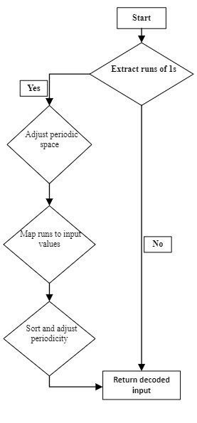

Fig 8: graphical representation of the decode method

